Pre-service music: Jazz carols from Jozef Janik (Organist and Choir Master)
Welcome and prayer: Rev Andrew Dand
Reading 1 – Isaiah 9:2-7
The people who walked in darkness have seen a great light: those who lived in a land of deep darkness—on them light has shined. You have multiplied the nation, you have increased its joy; they rejoice before you as with joy at the harvest, as people exult when dividing plunder. For the yoke of their burden, and the bar across their shoulders, the rod of their oppressor, you have broken as on the day of Midian. For all the boots of the tramping warriors and all the garments rolled in blood shall be burned as fuel for the fire. For a child has been born for us, a son given to us; authority rests upon his shoulders; and he is named Wonderful Counsellor, Mighty God, Everlasting Father, Prince of Peace. His authority shall grow continually, and there shall be endless peace for the throne of David and his kingdom. He will establish and uphold it with justice and with righteousness from this time onwards and for evermore. The zeal of the Lord of hosts will do this
Carols: O come, O come, Emmanuel & From the squalor
O come, O come, Emmanuel
1. O come, O come, Emmanuel,
And ransom captive Israel,
That mourns in lonely exile here
Until the Son of God appear.
Rejoice! Rejoice!
Emmanuel shall come to thee, O Israel.
2. O come O come Thou Lord of Might
Who to Thy tribes on Sinai's height
In ancient times didst give the law
In cloud and majesty and awe

3. O come thou rod of Jesse free
Thine own from Satan's tyranny
From depths of hell Thy people save
And give them victory o'er the grave

4. O come thou Dayspring come and cheer
Our spirits by Thine Advent here
Disperse the gloomy clouds of night
And death's dark shadows put to flight

5. O come Thou Key of David come
And open wide our heavenly home
Make safe the way that leads on high
And close the path to misery

From the Squalor
1. From the squalor of a borrowed stable,
By the Spirit and a virgin’s faith;
To the anguish and the shame of scandal
Came the Saviour of the human race.
But the skies were filled with the praise of heaven,
Shepherds listen as the angels tell
Of the Gift of God come down to man
At the dawning of Immanuel.
2. King of heaven now the Friend of sinners,
Humble servant in the Father’s hands,
Filled with power and the Holy Spirit,
Filled with mercy for the broken man.
Yes, He walked my road and He felt my pain,
Joys and sorrows that I know so well;
Yet His righteous steps give me hope again
I will follow my Immanuel.
Reading 2 – Luke 1: 26-38
In the sixth month the angel Gabriel was sent by God to a town in Galilee called Nazareth, to a virgin engaged to a man whose name was Joseph, of the house of David. The virgin’s name was Mary. And he came to her and said, ‘Greetings, favoured one! The Lord is with you.’ But she was much perplexed by his words and pondered what sort of greeting this might be. The angel said to her, ‘Do not be afraid, Mary, for you have found favour with God. And now, you will conceive in your womb and bear a son, and you will name him Jesus. He will be great, and will be called the Son of the Most High, and the Lord God will give to him the throne of his ancestor David. He will reign over the house of Jacob for ever, and of his kingdom there will be no end.’ Mary said to the angel, ‘How can this be, since I am a virgin?’ The angel said to her, ‘The Holy Spirit will come upon you, and the power of the Most High will overshadow you; therefore the child to be born will be holy; he will be called Son of God. And now, your relative Elizabeth in her old age has also conceived a son; and this is the sixth month for her who was said to be barren. For nothing will be impossible with God.’ Then Mary said, ‘Here am I, the servant of the Lord; let it be with me according to your word.’ Then the angel departed from her.
Reading 3 – Luke 2:1-7
In those days a decree went out from Emperor Augustus that all the world should be registered. This was the first registration and was taken while Quirinius was governor of Syria. All went to their own towns to be registered. Joseph also went from the town of Nazareth in Galilee to Judea, to the city of David called Bethlehem, because he was descended from the house and family of David. He went to be registered with Mary, to whom he was engaged and who was expecting a child. While they were there, the time came for her to deliver her child. And she gave birth to her firstborn son and wrapped him in bands of cloth, and laid him in a manger, because there was no place for them in the inn.

3. Through the kisses of a friend’s betrayal,
He was lifted on a cruel cross;
He was punished for a world’s transgressions,
He was suffering to save the lost.
He fights for breath, He fights for me,
Loosing sinners from the claims of hell;
And with a shout our souls are free –
Death defeated by Immanuel.

4. Now He’s standing in the place of honour,
Crowned with glory on the highest throne,
Interceding for His own beloved
Till His Father calls to bring them home!
Then the skies will part as the trumpet sounds
Hope of heaven or the fear of hell;
But the Bride will run to her Lover’s arms,
Giving glory to Immanuel!

Carol – Once in Royal David’s City (Choir)
1. (Solo verse)
Once in Royal David’s City
Stood a lowly cattle shed,
Where a mother laid her baby
In a manger for His bed.
Mary was that mother mild,
Jesus Christ, her little child.
2. He came down to earth from heaven,
Who is God and Lord of all,
And His shelter was a stable,
And His cradle was a stall:
With the poor and meek and lowly
Lived on earth our Saviour holy.
3. For he is our childhood's pattern;
Day by day, like us He grew;
He was little, weak and helpless,
Tears and smiles like us He knew;
And He feeleth for our sadness,
And He shareth in our gladness.
Reading 4 – Luke 2:8-20
In that region there were shepherds living in the fields, keeping watch over their flock by night. Then an angel of the Lord stood before them, and the glory of the Lord shone around them, and they were terrified. But the angel said to them, ‘Do not be afraid; for see—I am bringing you good news of great joy for all the people: to you is born this day in the city of David a Saviour, who is the Messiah, the Lord. This will be a sign for you: you will find a child wrapped in bands of cloth and lying in a manger.’ And suddenly there was with the angel a multitude of the heavenly host, praising God and saying, ‘Glory to God in the highest heaven, and on earth peace among those whom he favours!’ When the angels had left them and gone into heaven, the shepherds said to one another, ‘Let us go now to Bethlehem and see this thing that has taken place, which the Lord has made known to us.’ So they went with haste and found Mary and Joseph, and the child lying in the manger. When they saw this, they made known what had been told them about this child; and all who heard it were amazed at what the shepherds told them. But Mary treasured all these words and pondered them in her heart. The shepherds returned, glorifying and praising God for all they had heard and seen, as it had been told them.
4. And our eyes at last shall see Him
Through His own redeeming love;
For that child, so dear and gentle,
Is our Lord in heaven above;
And He leads His children on
To the place where He is gone

5. Not in that poor lowly stable,
With the oxen standing by,
We shall see Him, but in heaven,
Set at God's right hand on high;
When like stars His children crowned,
All in white shall wait around.
Carol – Hark the Herald Angels Sing (Choir)
1 Hark! the herald angels sing,
"Glory to the newborn King:
peace on earth, and mercy mild,
God and sinners reconciled!"
Joyful, all ye nations, rise,
join the triumph of the skies;
with th'angelic hosts proclaim,
"Christ is born in Bethlehem!"
Hark! the herald angels sing,
"Glory to the newborn King"
2 Christ, by highest heaven adored,
Christ, the everlasting Lord,
late in time behold him come,
offspring of the Virgin's womb:
veiled in flesh the Godhead see;
hail th'incarnate Deity,
pleased with us in flesh to dwell,
Jesus, our Immanuel.
Hark! the herald angels sing,
"Glory to the newborn King"
Reading 5 – John 1:1-5
In the beginning was the Word, and the Word was with God, and the Word was God. He was in the beginning with God. All things came into being through him, and without him not one thing came into being. What has come into being in him was life, and the life was the light of all people. The light shines in the darkness, and the darkness did not overcome it.
Address: Rev Susy Dand
Carol – Like a Candle Flame (Choir)
Like a candle flame
Flickering small in our darkness
Uncreated light
Shines through infant eyes
God is with us, alleluia (Men)
God is with us, alleluia (Women)
Come to save us, alleluia (Men)
Come to save us (Women)
Alleluia! (All)
Stars and angels sing
Yet the earth sleeps in shadows
Can this tiny spark
Set a world on fire?
God is with us, alleluia…
Yet his light shall shine
From our lives, Spirit blazing
As we touch the flame
Of his holy fire
God is with us, alleluia…
3 Hail the heaven-born Prince of Peace!
Hail the Sun of Righteousness!
Light and life to all he brings,
risen with healing in his wings.
Mild he lays his glory by,
born that we no more may die,
born to raise us from the earth,
born to give us second birth.
Hark! the herald angels sing,
"Glory to the newborn King"

Prayers: Rev Helen Cosstick
Carol – O Come All Ye Faithful (Choir)
3. Sing, choirs of angels,
Sing in exultation,
Sing all ye citizens of heaven above
Glory to God in the Highest;
O come, let us adore Him,
O come, let us adore Him,
O come, let us adore Him,
Christ the Lord.

1. O Come All Ye Faithful
Joyful and triumphant,
O come ye, O come ye to Bethlehem.
Come and behold Him,
Born the King of Angels;
O come, let us adore Him,
O come, let us adore Him,
O come, let us adore Him,
Christ the Lord.
4. Ye Lord, we greet Thee,
Born that happy morning,
Jesu, to thee be glory given,
Word of the Father, now in flesh appearing;
O come, let us adore Him,
O come, let us adore Him,
O come, let us adore Him,
Christ the Lord.

2. God of God,
Light of Light,
Lo he abhors not the virgin’s womb,
Very God
Begotten not created.
O come, let us adore Him,
O come, let us adore Him,
O come, let us adore Him,
Christ the Lord.

Final Blessing: Rev Andrew Dand
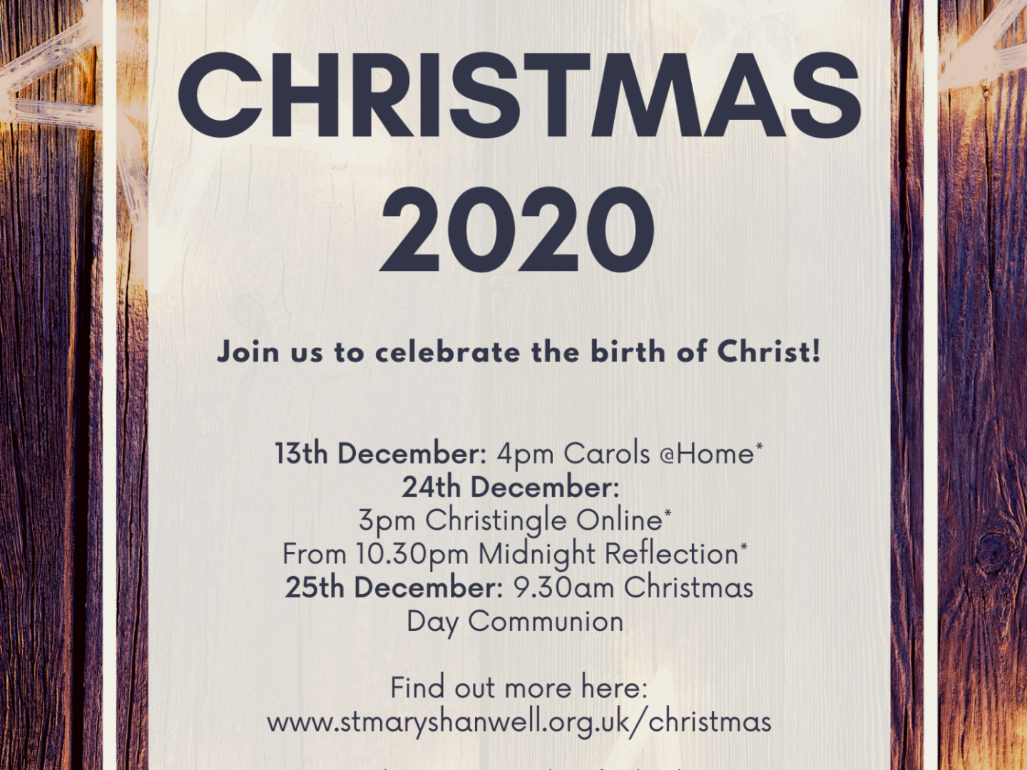
Online Giving
Everything we do in mission and ministry is made possible by the generous support of our church family. We encourage everyone who is a regular member of St Marys to join our planned giving scheme (standing order) as this helps us to plan and budget.

You can now make donations online as a one off or regular gifts, and every penny goes back into enabling our mission and ministry.

Details of how to give online or join the planned giving scheme can be found online @ www.stmaryshanwell.org.uk/giving

